**Mohammed Mahin Ibnay Mamun (346584)**

**Unit 11 Assignment Task 2**

**An introduction to the design work:**

In this task, I need to produce a brief video clip for this work which lasts 15-20 seconds. The following objects I will need in the clip to tell this story are:

* A pathfinder ship with a capacity of 600 people which has some sort of system to defend against enemies (e.g - turret, lasers, rockets).
* A space stations used in the clip for our pathfinder to fly cross.
* A planet which our pathfinder can fly past.
* An enemy ship our pathfinder can attack
* A logo or banner designed to be a title screen

My video design will consist of all the listed above. There will be a pathfinder flying past a space station where an enemy is spotted. Causing the pathfinder to charge with its weapons. This will cause the planets to get damaged which will result in repulsing letter which makes up a banner towards the end.

**Platform**

The video clip which I create will be streaming on a web stream. The overall platform is the web. Viewers can watch this live stream from across the world through web access.

**Hardware needed**

The hardware which I will need to complete this task are listed below:

* Computer
* Mouse
* Keyboard
* Pen and paper
* Digital graphics tablet (preferably)
* Internet connection (via Wi-Fi)

**Software**

To create this animation, I will need the following software's:

* Microsoft office (word/PowerPoint)
* Notepad
* 3ds max
* Photoshop
* Excel

**A time plan showing the timescales from design to completed video file**

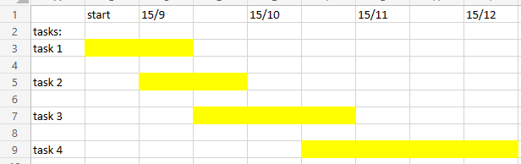

Task 4 which is the actual creation will take the longest and will start before task 3 is finished.

In task 1 I will spend most of the time researching about digital animations and learning more about it. I will be making notes on the key aspects.

Task 2 I will start designing some drafts and a final for a logo, spaceships, planets, and space station design.

During task 3 I will get feedback from peers and outsider. This feedback will be on my design, and I will make some changes based on the feedback I received.

**What you have been asked to design**

* Spaceship
* Space station
* Enemy ship
* Planets
* Logo

**What are the legal and ethical considerations one should be aware of when creating digital images?**

There are a few laws and ethics which must be followed when creating a digital image. The most common is the Copyright, Designs and Patents Act 1988. This gives you creativity of a design, music, or any illustration. By using someone Elses can get you into trouble. When creating a digital image, you must create your own and not use others unless they give you permission, which can be done by contacting them and making an agreement (cash fee).

Another legal and ethical consideration, also well known, is the current law governing trademark registration and registered trademark protection in the UK is the Trademarks Act 1994, as amended. trademark can also be found in images just like copyright.



**File formats**

|  |  |  |  |
| --- | --- | --- | --- |
| **File type and settings** | **File size** | **Comments on quality etc.** | **image** |
| PSD (no changes) | 5.43 MB | High quality image. |  |
| JPG (100% Quality) | 687 KB / 704.162 bytes | File size drops, image uses less colors which makes it looked smudged. |  |
| JPG (50% Quality) | 119 KB / 122.826 bytes | File size drops, not much difference from 100% and very hard to spot changed |  |
| JPG (20% Quality) | 64.1KB / 65.708 bytes | Smaller file size, image looks similar but very blocky when you zoom in |  |
| PNG (24 bit) | 1.47 MB / 1,543.335 bytes | File size increased, photo looks in-between jpg 100% and 50%. There is no big pixels appearing(blocky). There is not much smudge of color |  |
| GIF | 497 KB / 509.180 bytes | Areas of the photo look like they have been compressed. As you zoom in you can see loss of quality, lots of pixels (blocks) appearing Aswell as multiple shaded of color. |  |

**Using the original image again.**

|  |  |  |  |
| --- | --- | --- | --- |
| **Size and Filetype** | **File size** | **Comments on Quality etc.** | **image** |
| PSD (500 x 500) |  |  |  |
| PNG (500 x 500) | 495 KB / 507.247 bytes | File size is compress by 1mb just by adjusting the size of the image. Photo looks similar as before, once zoomed in you can start to see pixels and different shaded of color. |  |
| GIF (500 x 500) | 143 KB / 146.754 bytes | Due to compressing the image size, the file size has also decreased. You can tell right away it has been compressed, a lot less use of color which results in more smudges. Photo is still clear but very much difference from original. When zoomed, image appears very pixelated and smudged. |  |
| JPG 100% (500 x 500) | 100% 252 KB / 258.419 bytes  Lowest quality % drops to 17KB | Better quality than GIF and this jpg has a less smudge compared to Png.  Image looks quality isn't decreased much from 1000x1000 jpg 50%. |  |

***Photoshop – Image - Adjustments***

|  |  |
| --- | --- |
| **Changes made** | **Effects** |
| Adjusting brightness and contrast | Low brightness low contrast, photo is very dark, still noticeably clear when zoomed in, not pixelated, or smudged. The bit depth remains the same. File size = 1.21 MB, origin was 5.43 MB, reducing brightness and contrast has a big decrease on file size.  High brightness, sharp contrast. This makes the image look very vibrant and make u think they have used less but brighter colors. The areas of the photo look more smudged with less use of color shaded. although Image does not look pixelated it looks very smudged. File size= 1.27 KB,higher than poor brightness and contrast but much less than original I think due to color depth |
| Adjusting Hue/Saturation settings | Low hue and saturation makes the image a monochrome of only 2 colors (black and white.) quality of the image looks the same, no pixelated / smudged areas. File size, which was originally 5.43 MB drops drastically to 773 KB  High hue and saturation contrast to low which gives our image an extremely high rgb overall color with a few other shades. The main colors displayed are red and blue alongside other shades. file size has decreased from 5.43 MB to 1.31MB. |
| Adjusting Color Balance settings | You can use this color balance scale to make your image have an overall shade. If you try to increase all values to poor or high like this example below:    This will make your image go back to the original. Which will allow the image to keep the same file size and resolution. |
| Inverting the image | To the left is the image I received when I inverted the image. The effect taking place in the invert tool is: photoshop is flipping your colors from RGB to CMY. This links with the color balance settings. If my image was on red 50 green 25 and I invert the image with this tool, I will result in cyan -50 and green –25. Using this effect dropped out file size from 5.43 down to 1.46 MB |

***Photoshop – Image – Mode***

|  |  |
| --- | --- |
| **Changes made** | **Effects** |
| Greyscale | Applying greyscale to your image gives you the same result as low hue and saturation. Once again, the image uses an exceptionally low color bit depth which gives a monochrome image. Applying this effect has dropped the image file size down by 4.6 KB |
| CMYK |  |

**Sources of any external assets (textures etc) and Texture designs for 3D models**

Source:

([planet texture maps - Bing images](https://www.bing.com/images/search?view=detailV2&ccid=Vk1wwn3x&id=F7B1E02AE2D1850B6D8E7FF4BED180941A45965D&thid=OIP.Vk1wwn3xngsNwxDXs28tAQHaDt&mediaurl=https%3a%2f%2fth.bing.com%2fth%2fid%2fR.564d70c27df19e0b0dc310d7b36f2d01%3frik%3dXZZFGpSA0b70fw%26riu%3dhttp%253a%252f%252feoimages.gsfc.nasa.gov%252fimages%252fimagerecords%252f73000%252f73580%252fworld.topo.bathy.200401.3x5400x2700.jpg%26ehk%3dZN9y1kUKg9JOgktQ0m23CFx7riJdBXW%252bux0nI8bCFts%253d%26risl%3d1%26pid%3dImgRaw%26r%3d0&exph=2700&expw=5400&q=planet++texture+maps&simid=608029630031401786&FORM=IRPRST&ck=AB7BEAA82C5F0C1012E437FD1C358EAA&selectedIndex=0&qft=+filterui%3aimagesize-large&ajaxhist=0&ajaxserp=0)).

(https://i.ytimg.com/vi/nUWfZfsW7uU/maxresdefault.jpg)

(<https://theleveragists.com/wp-content/uploads/2016/03/texture_mercury.png>)

(https://cdn.quotesgram.com/img/13/62/596287031-texture_venus_surface.jpg)

(https://img1.goodfon.com/wallpaper/nbig/7/af/mars-poverhnost-tekstura-fon.jpg)

(https://th.bing.com/th/id/R.44cb83f391498a2733a72bf8c97114dc?rik=5NWLG6yl1NkUWg&riu=http%3a%2f%2fplanetpixelemporium.com%2fdownload%2fdownload.php%3fjupiter2_4k.jpg&ehk=PsJ7d6p9AWs56XkBbgJEtjiX9EGrKWo8lsEENXonPyE%3d&risl=&pid=ImgRaw&r=0)

(https://th.bing.com/th/id/OIP._AdcrXGrbtMvGInMTS7gWQHaDb?pid=ImgDet&rs=1)

(https://orig00.deviantart.net/e7d6/f/2018/026/c/1/uranus_texture_map_2017_by_magentameteorite-dc18wwb.jpg)

(https://th.bing.com/th/id/OIP.uRGHTJLpLqmNltUHqfYTwgHaDt?pid=ImgDet&rs=1)

(https://th.bing.com/th/id/OIP.pXzuPgKaacrEHr98uEN0BgHaEb?pid=ImgDet&rs=1)

**Designs for the images/models**

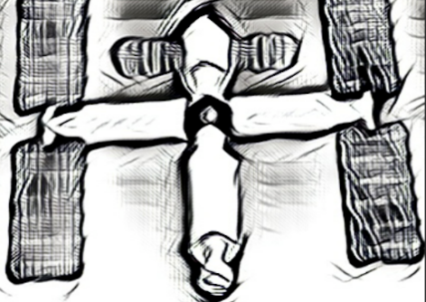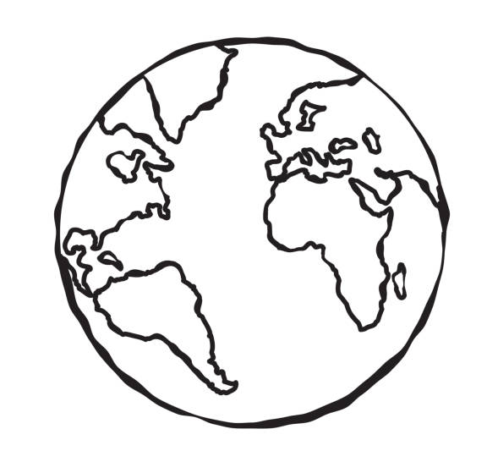

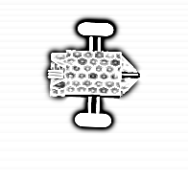

**Storyboards**

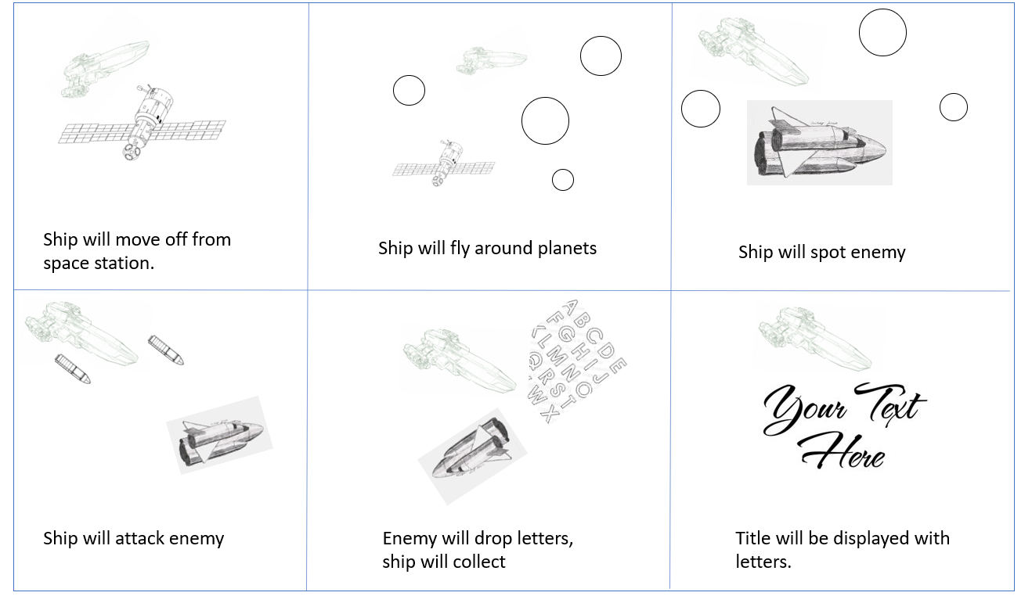

**Logo**

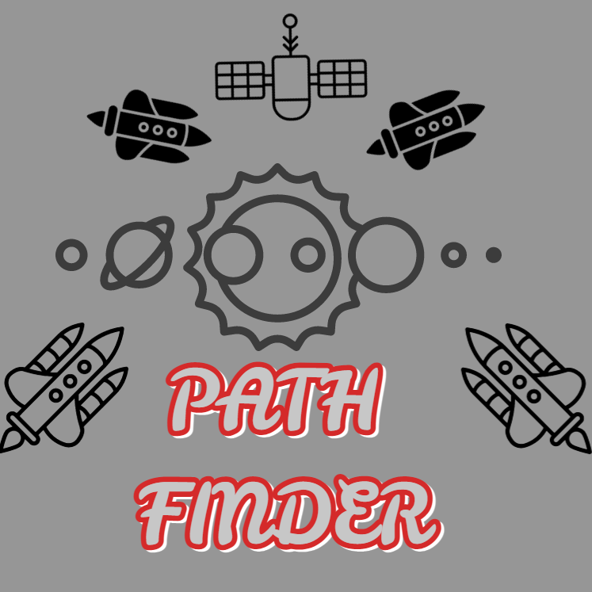

**Space station 3d design**

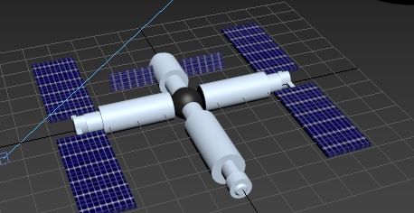

**Ship 3d design**

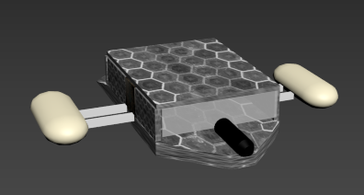  
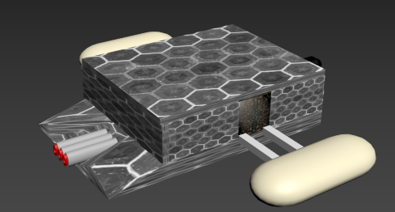  
**Planets 3d design**

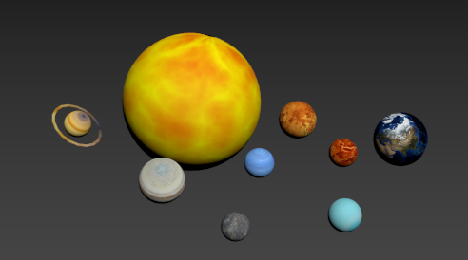

**Feedback and review**

I asked a few people about my work and which areas they liked most and which they think can be improved. Starting with the storyboard, everyone that I asked said it made sense to them and it was interesting. A few people said it is quite basic, but I had to explain that the final design will only be 15-20 seconds.

Everyone said they liked the planets and how I used different textures to clearly show which planet is which.

On the ship, someone said it is too basic and I should make it look more like a ship. Out of everything I received the most positive feedback for the space station. Everyone really liked the design and they all agreed that the textures suit well with it.